**Job Steps:**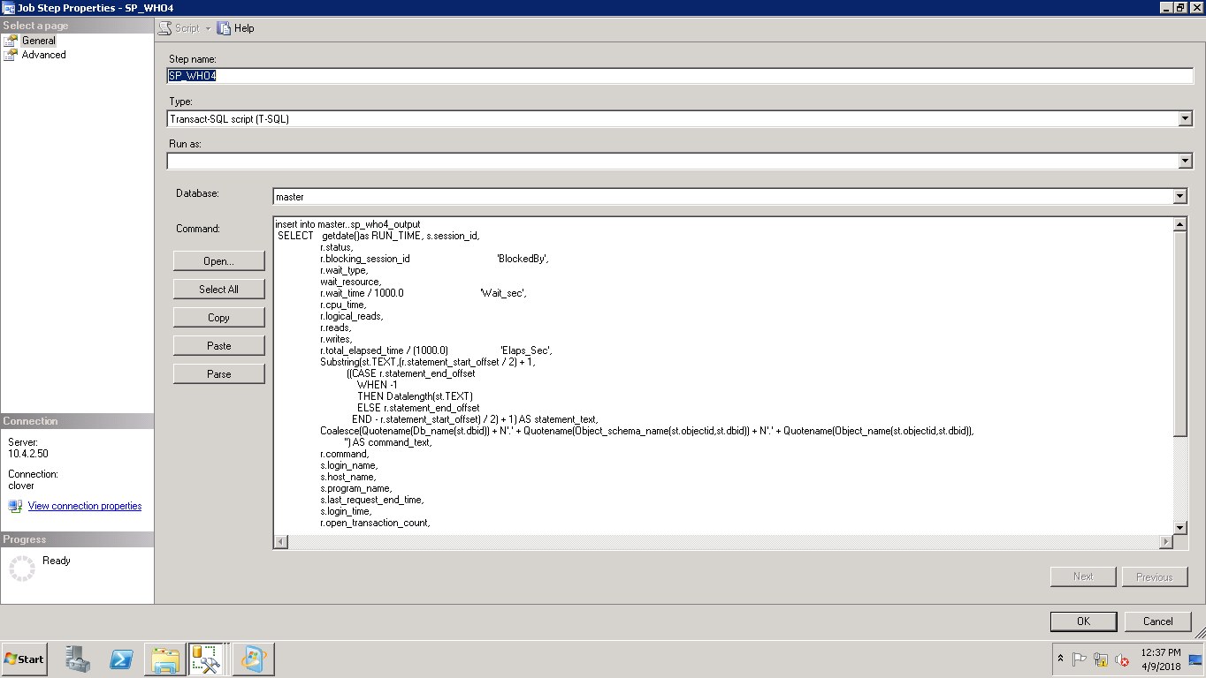

**Schedule:** 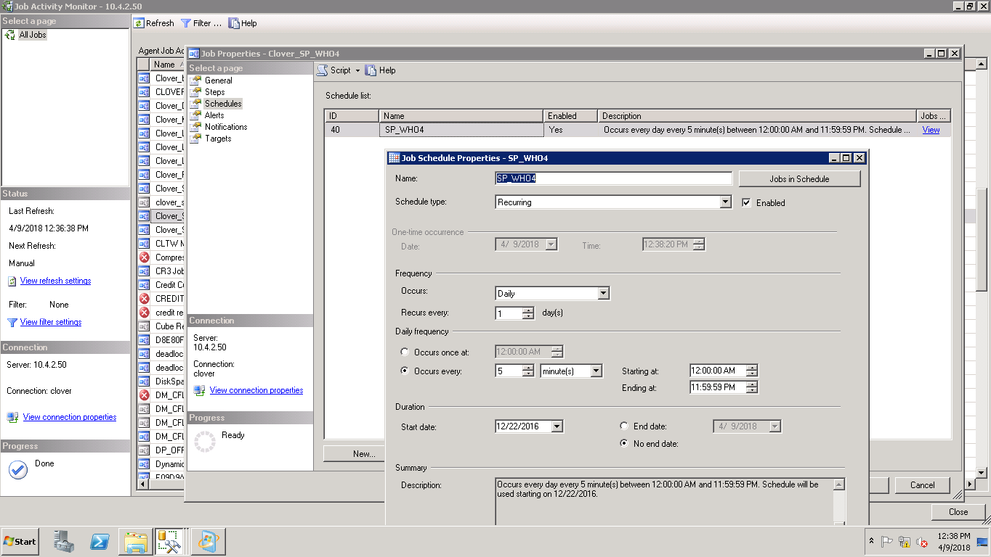

**First Create Table:**

USE [master]

GO

/****** Object: Table [dbo].[sp_who4_output]

SET ANSI_NULLS ON

GO

SET QUOTED_IDENTIFIER ON

GO

CREATE TABLE [dbo].[sp_who4_output](

[CURRENTDATE] [datetime] NOT NULL,

[session_id] [smallint] NOT NULL,

[status] [nvarchar](max) NOT NULL,

[BlockedBy] [smallint] NULL,

[wait_type] [nvarchar](max) NULL,

[wait_resource] [nvarchar](max) NOT NULL,

[Wait_sec] [numeric](17, 6) NULL,

[cpu_time] [int] NOT NULL,

[logical_reads] [bigint] NOT NULL,

[reads] [bigint] NOT NULL,

[writes] [bigint] NOT NULL,

[Elaps_Sec] [numeric](17, 6) NULL,

[statement_text] [nvarchar](max) NULL,

[command_text] [nvarchar](max) NULL,

[command] [nvarchar](max) NOT NULL,

[login_name] [nvarchar](max) NOT NULL,

[host_name] [nvarchar](max) NULL,

[program_name] [nvarchar](max) NULL,

[last_request_end_time] [datetime] NULL,

[login_time] [datetime] NOT NULL,

[open_transaction_count] [int] NOT NULL,

[database_name] [nvarchar](max) NULL

) ON [PRIMARY] TEXTIMAGE_ON [PRIMARY]

GO

**Query for job:**

insert into dbo.sp_who4_output

SELECT getdate()as RUN_TIME, s.session_id,

r.status,

r.blocking_session_id 'BlockedBy',

r.wait_type,

wait_resource,

r.wait_time / 1000.0 'Wait_sec',

r.cpu_time,

r.logical_reads,

r.reads,

r.writes,

r.total_elapsed_time / (1000.0) 'Elaps_Sec',

Substring(st.TEXT,(r.statement_start_offset / 2) + 1,

((CASE r.statement_end_offset

WHEN -1

THEN Datalength(st.TEXT)

ELSE r.statement_end_offset

END - r.statement_start_offset) / 2) + 1) AS statement_text,

Coalesce(Quotename(Db_name(st.dbid)) + N'.' + Quotename(Object_schema_name(st.objectid,st.dbid)) + N'.' + Quotename(Object_name(st.objectid,st.dbid)),

'') AS command_text,

r.command,

s.login_name,

s.host_name,

s.program_name,

s.last_request_end_time,

s.login_time,

r.open_transaction_count,

Db_name(r.database_id)

FROM sys.dm_exec_sessions AS s

JOIN sys.dm_exec_requests AS r

ON r.session_id = s.session_id

CROSS APPLY sys.Dm_exec_sql_text(r.sql_handle) AS st

ORDER BY r.status,

r.blocking_session_id,

s.session_id

**2.Delete Step:**

delete FROM sp_who4_output   
WHERE CURRENTDATE <= DATEADD(day,-30, getdate())